From: James Guthrie <jguthrie@lifesaving.com.au>
Sent: Wednesday, 28 May 2025 3:39 PM
Subject: Branch Bronze and SRC courses

Hi team,
Please see below some important info about a couple of branch courses coming up for Surf Rescue Certificate and Bronze Medallion.
1 – Intensive Bronze Medallion at Etty Bay SLSC:
When: Saturday 28th June until Tuesday July 1st. It will run over the 4 consecutive days between 9:00am and approx. 3:30pm
This will be open to members from across the branch and the option to sleep at the club house will be available. This will be dependent on the correct number of chaperones being available for the 18’s.
2- Intensive under 15’s SRC camp at Cairns SLSC:
When – Friday July 11th until Sunday July 13th. This will be a live in camp for 13/14-year-olds, as well as the parents of those kids participating should they want to join in.
Again, this will need to be supported by some chaperones for the weekend so we can ensure we maintain the safety and welfare of those involved.

Enrolments:
To enrol in either of these courses, please follow the instructions below. For those who haven’t done a course through surf before, particularly the 13-year-olds who are on a family membership, please ensure you have your own email address and have your own SLSA members area log in as well as a USI before enrolling.
USI’s can be created by going to Home page | Unique Student Identifier.

To enrol, please visit the SLSQ Hub (Home) and find the course list.
**If you have usually operated on a family membership, please create an SLSA members portal log in for your child/yourself as everyone needs to have their own access and use their own individual email to enrol, not a family email. This can be done by clicking the link below and then creating an account, as per the picture below also.
SLS Members Area - Login

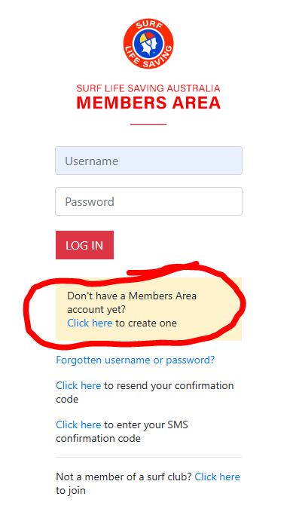

Once you have access to the SLSA Members Area, please click on the ‘eLearning’ tab at the top of the page. If this then asks you to log in to eLearning, please use the same username and password you used for the SLSA Members Area. This will take you to the SLSQ Hub.

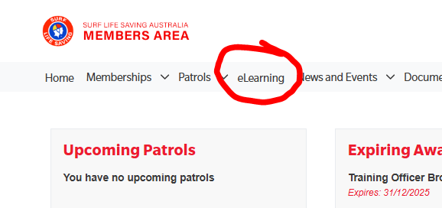

Once in the SLSQ Hub, you may will need to make sure you have the appropriate green ticks down the side (over 18’s need all of them, under 18s just need the membership and financial). If you need to complete the CYRMS/CSA, please click the box to do so.
If you have the correct ticks, please click the Course List button.
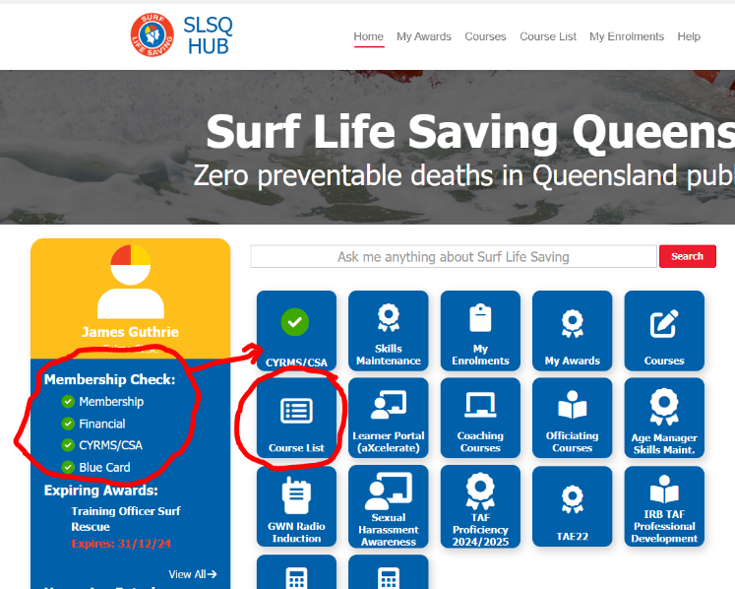

Once in the course list, you may need to untick the ‘My Club Only’ box, but you will see the different course options.. Please enrol in the highlighted course.

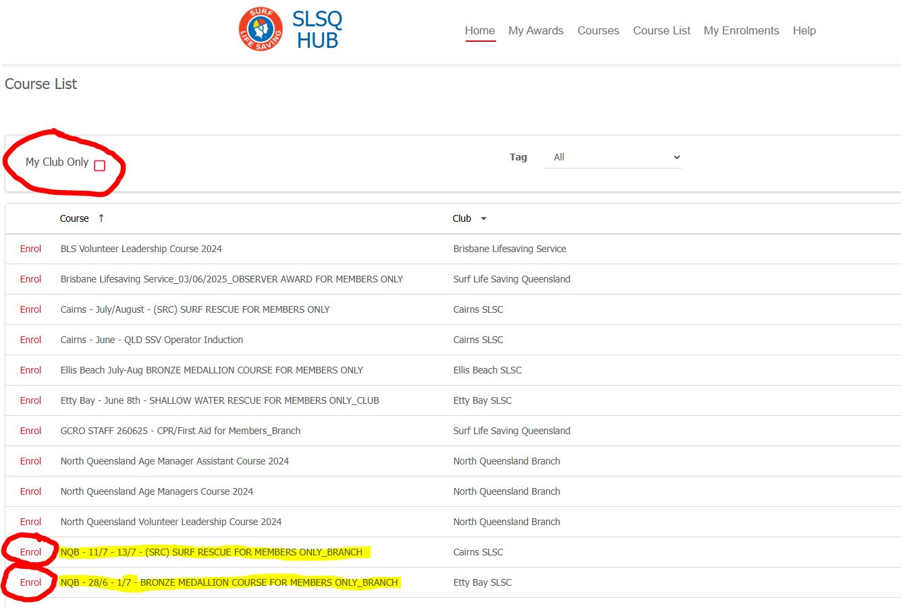

Once you complete your enrolment, you will receive an email to say you are tentatively booked until you are confirmed onto the course (manually done so please give it 24hours). Once confirmed another email to say you are ‘Booked’ will come through.
If you have never done a course with SLSQ, you will also receive an email titled ‘aXcelerate User Account’. Please click the link in that email to set up your password for aXcelerate.
aXcelerate is our learning management system where all your theory components and assessments are completed. If you have any issues or questions around that please let me know.

Any other questions, please refer them to me 😊
Cheers,
James


James Guthrie | Education & Training Supervisor North Queensland
Surf Life Saving Queensland
PO Box 201, Smithfield QLD 4878 | 26 Leisure Park Road, Smithfield QLD 4878
ph. +61 7 4049 1204 | m. +61 457 003 029 | f. +61 7 3846 8008 | w. lifesaving.com.au
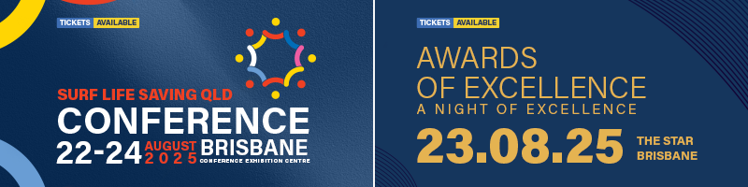
Surf Life Saving Queensland acknowledges the Traditional Custodians of our lands and waterways. We pay our respects to Elders past and present. We also extend that respect to all Aboriginal and Torres Strait Islander Peoples.
This e-mail message and any attached files may contain information that is copyright or confidential. It has been prepared for the private and confidential use of the intended recipient and may not be disclosed to anyone else. Any review, re-transmission, disclosure, dissemination or other use of, or taking of any action in reliance upon, this information by persons or entities other than the intended recipient is unauthorised. If you have received this e-mail in error, please notify us immediately by reply e-mail and delete this e-mail together with any attachments. Surf Life Saving Queensland does not represent this e-mail to be free from any virus, fault or defect and it is therefore the responsibility of the recipient to first scan it for viruses, faults and defects.

